# artist palette UI/UX Design Principles & UI Design with Figma

**WIFI** Second Home Guest

**PASSWORD**: welcomehome

# Who?

# Celina Cabral

 Independent  Designer (UX/UI Design and Branding)

[www.celinacabral.com](http://www.celinacabral.com)

For more than 12 years I've been using design as transformative tool that can change companies and services, offering better human relationships through interfaces, products and a worth brand experience.

## Why design is important?

With technology going so fast, how digital products and companies could stand out and deliver better and easier human interactions?

## Why learning design?

Trying to communicate anything for human interaction could be a hard task.



## Design for the digital interaction

Imagine how things could be without design.

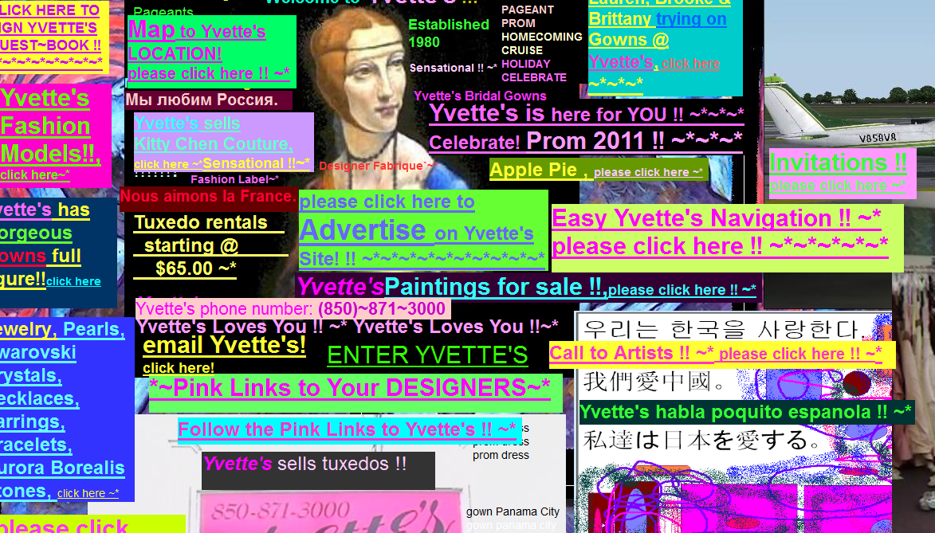

But luckily we have many tools to help, and just **before coding** you can have a real visual prototype to see how it's going to look and have basis for developers to work with.

Today we're going to learn some design basics and learn to prototype a real website in **Figma.**

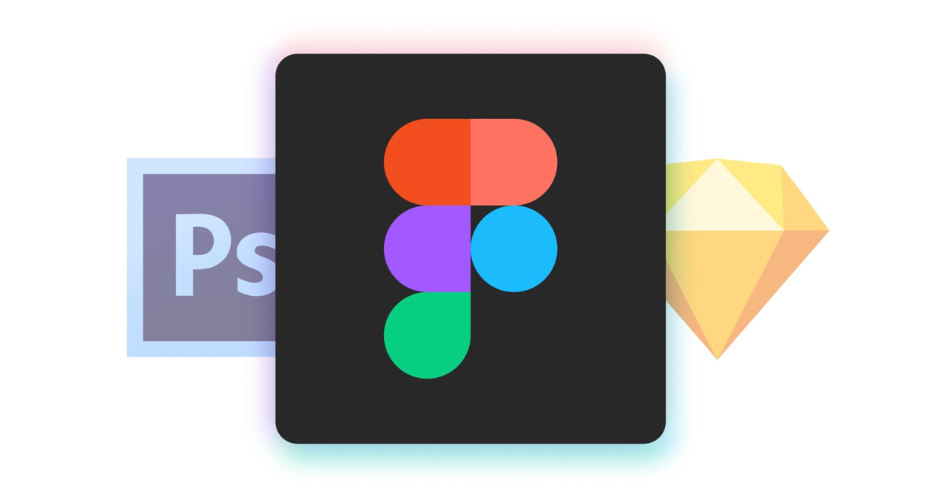

# 1. Defining Design

## Design is about planning, defining standards and creating system for any human interaction.

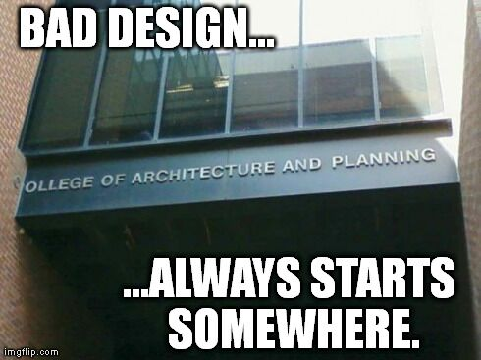

# 1.1 Evolution of Design Disciplines

 Graphic Design

 Packaging Design

®️ Branding Design

 Product Design / Industrial Design

  Interior Design

  Motion Design

**But then we got surrounded by a new scenario…and some jobs, reinvented!**



## woman technologist Web Design

## ️mobile phone Digital Product Design

## mobile phone with arrow Interaction Design (IxD)

## eye User Interface Design (UI)

## red heart  User Experience Design (UX)

# 1.2  User Interface Design (UI)

User Interface Design is the discipline of designing interfaces for devices, applications  websites with a focus on maximising efficiency, responsiveness and aesthetics to foster a good interaction.

**The interface should allow a user to perform any required tasks to complete the function of the product or service.**

## artist palette UI Designers are responsible for the the end result of an interface:

* Graphics, Icons and Buttons
* Typography
* Colors
* Composition, usability

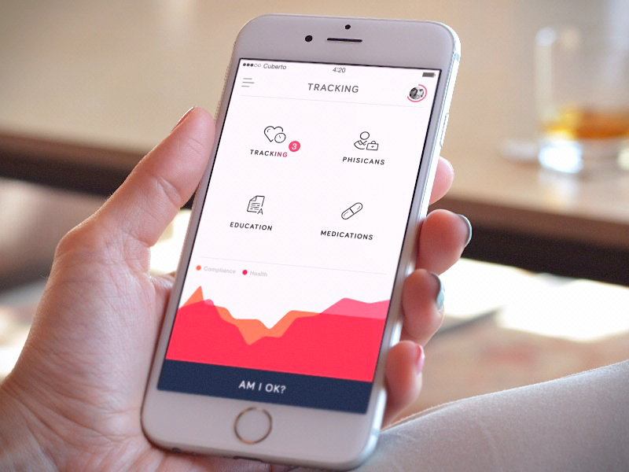

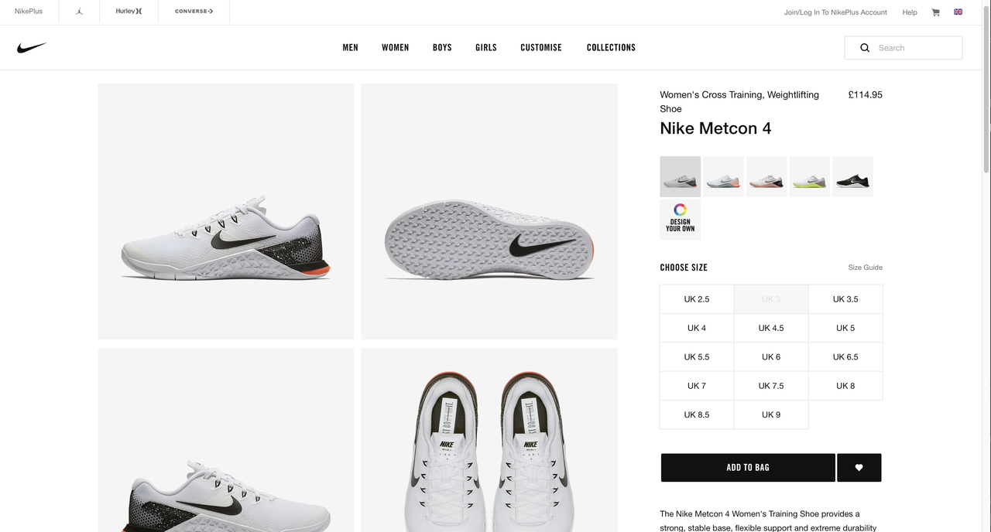

# 1.3 User Experience Design (UX)

User experience design is process of enhancing user satisfaction with a product by improving the **usability**, **accessibility**, and **pleasure** provided in the interaction with the product.

Is studying **user behaviour** and understanding user motivations with the goal of designing better digital experiences.

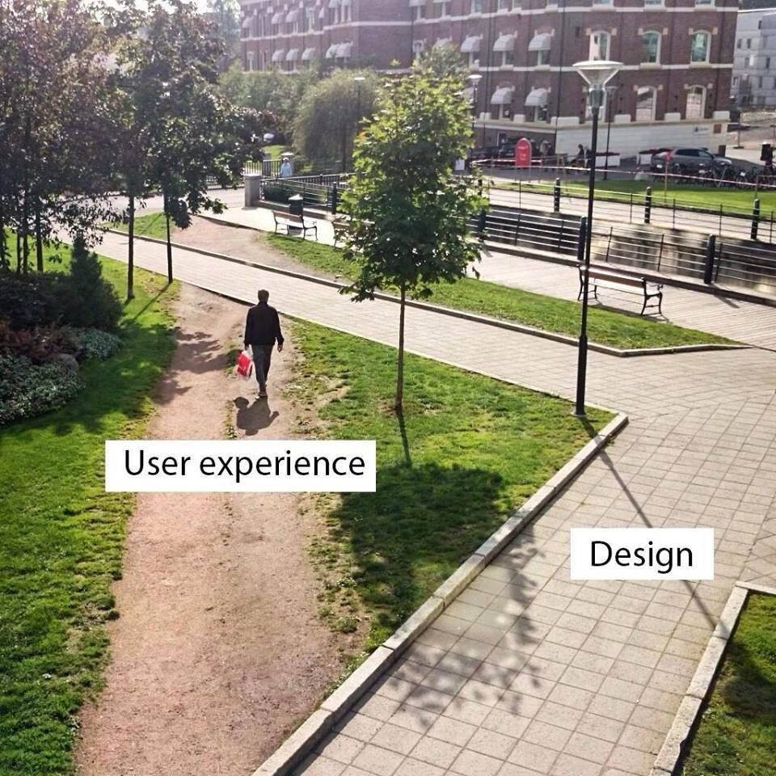

## brain UX Designers are part of the full product design process:

* Visual Design
* Interface and Interactions
* Information Architecture
* Strategy and goals

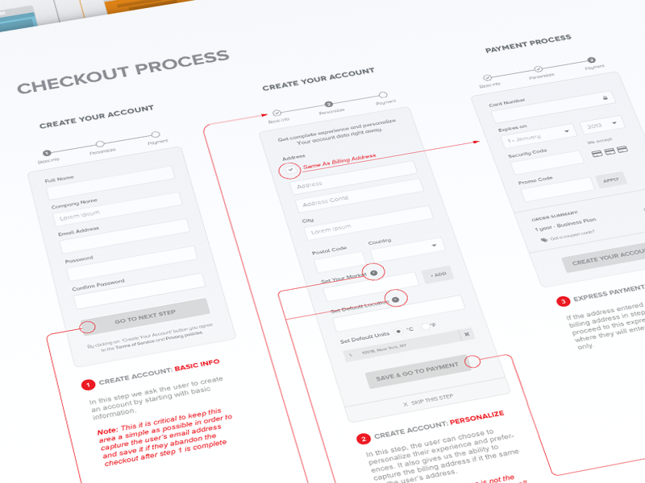



# 2. Understanding the Webdesign evolution

## 1992  - The very first website

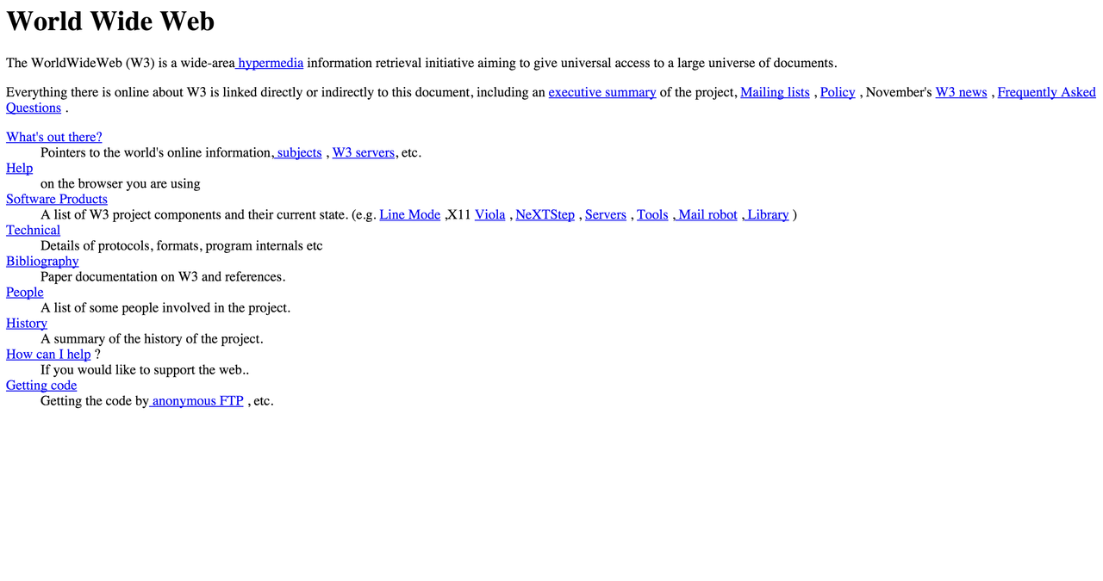

## 1996 - Beginning  of usability

Internet users more than doubled in the year 1996 to 36 million users world wide. [CNN’s 1996 year in review](http://www.cnn.com/EVENTS/1996/year.in.review/) is an iconic web page. Using text, images and ads, CNN presented a balanced site design with great usability for the mid 90’s.

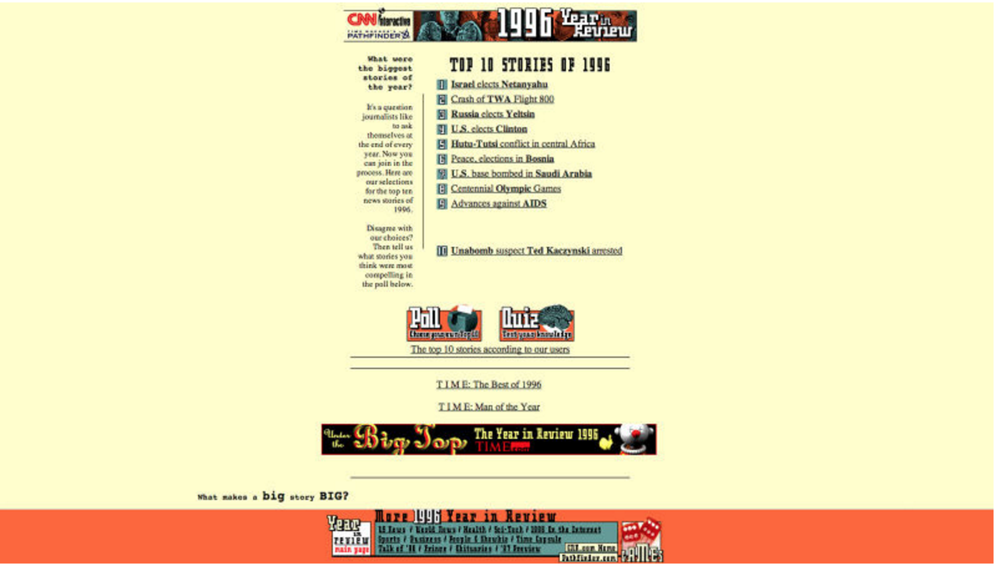

## 2000 The Online Economy: Business starting going online

In the year 2000 [PayPal](https://www.paypal.com/) took off. As more and more businesses were going online, having a great looking website was starting to become more than a want, it was becoming a need.

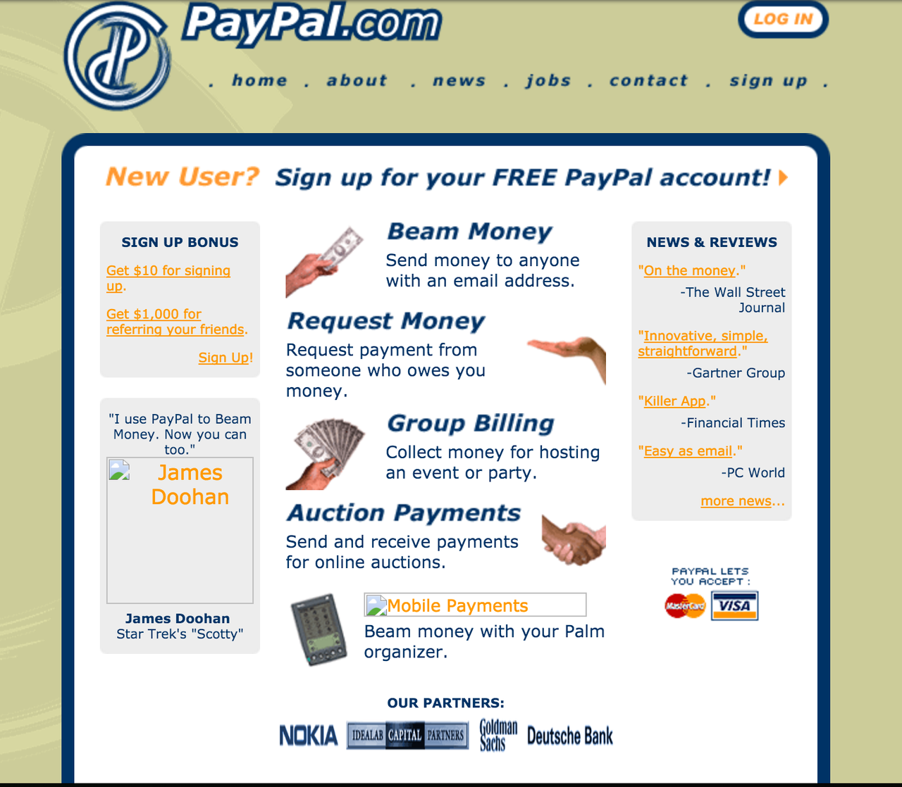

## 2003 - 2007  Getting more personal: blog and social media

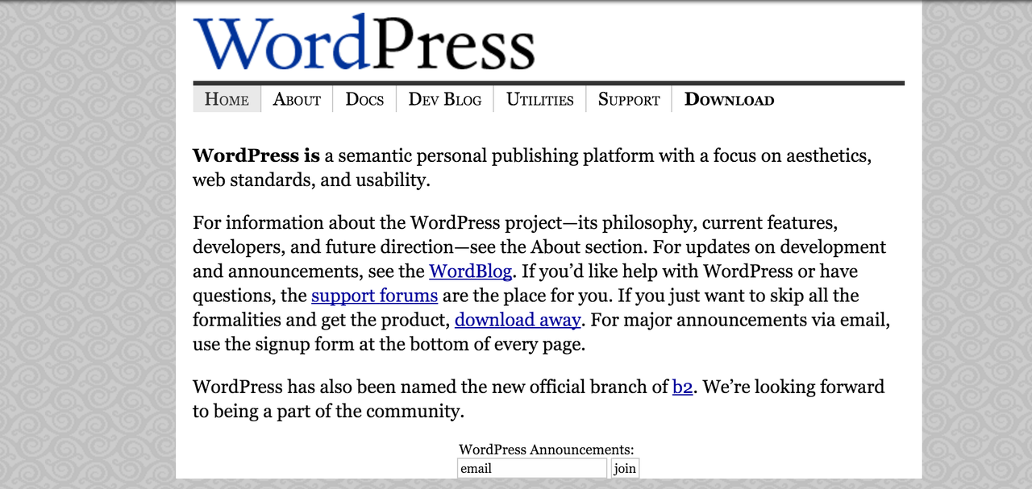

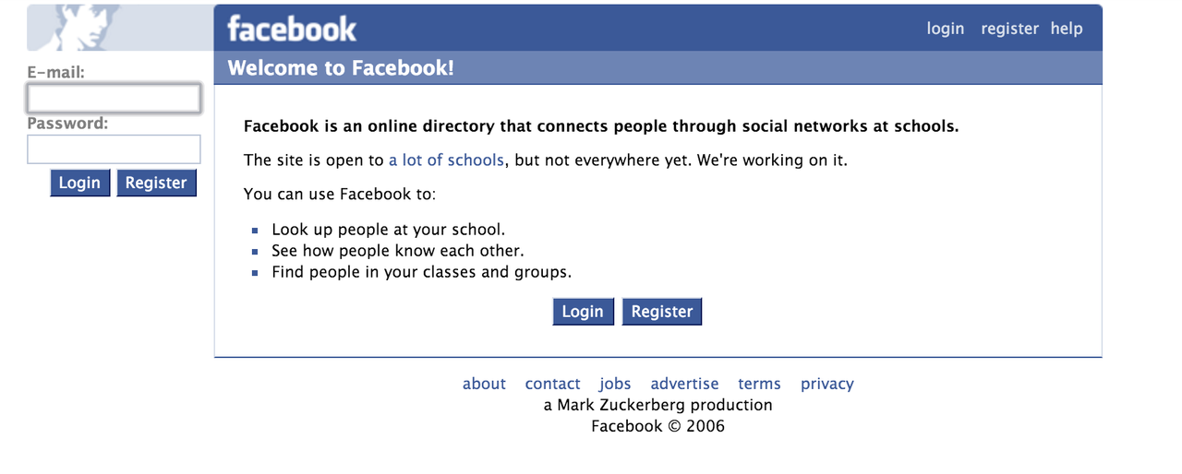

## 2007 – The Mobile Revolution

On June 29, 2007 the first iPhone was released ushering in a new era of web design.

## 2010 - The Responsive Design

In 2010 the wedesigner [Ethan Marcotte](http://ethanmarcotte.com/) challenge the way mobile website design was being approached. Instead of creating a separate mobile site, he proposed that the same content could be used, but in different layouts and designed depending on screen size. This was the birth of **Responsive Design.**

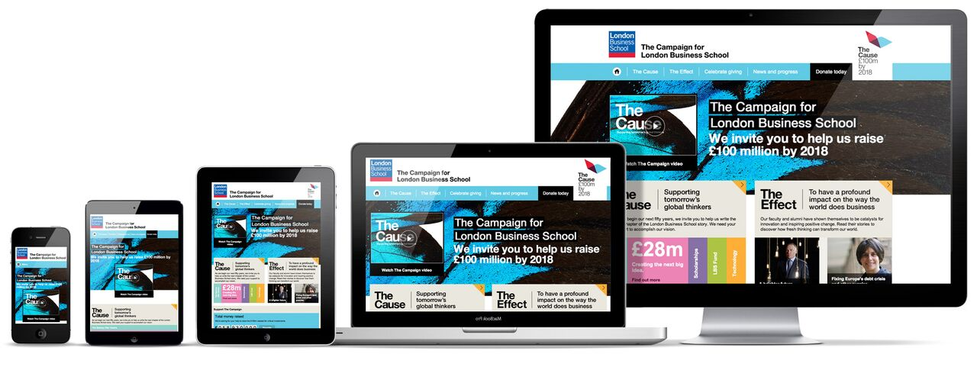

+ More content: [A brief story of Webdesign](http://blog.froont.com/brief-history-of-web-design-for-designers/)

# 3. Terminology

## 3.1 Understanding the Size Unit: Pixels

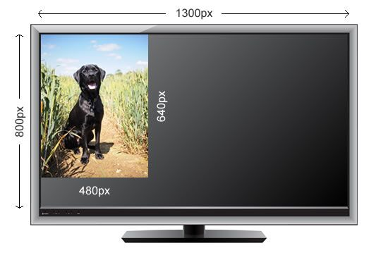

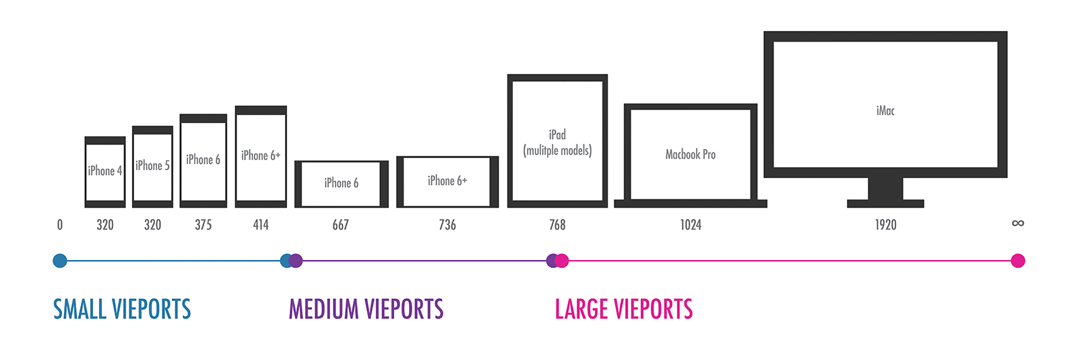

## 3.2 Responsive and  Mobile First

Who is your main audience?

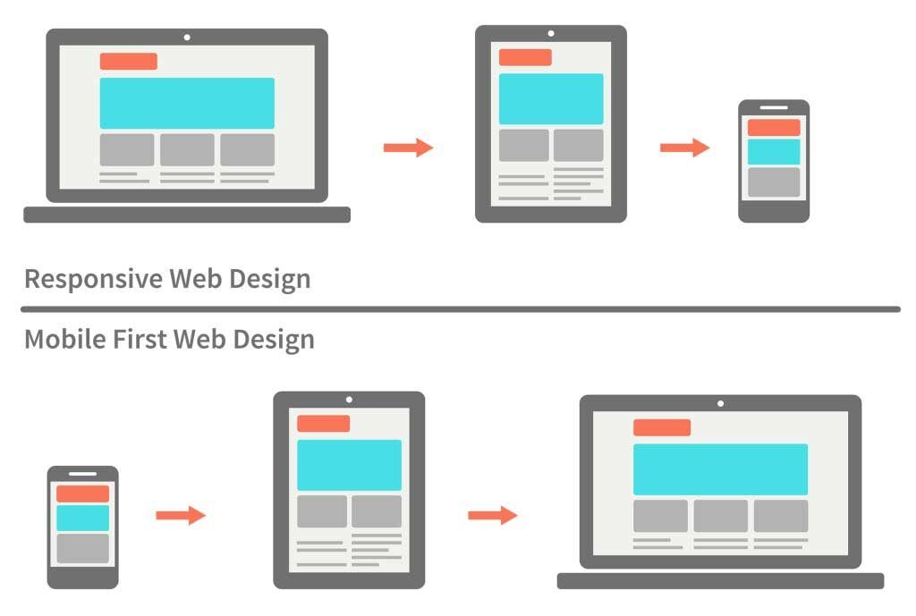

## 3.3 Basic Elements to know

**3.3.1 Structure**

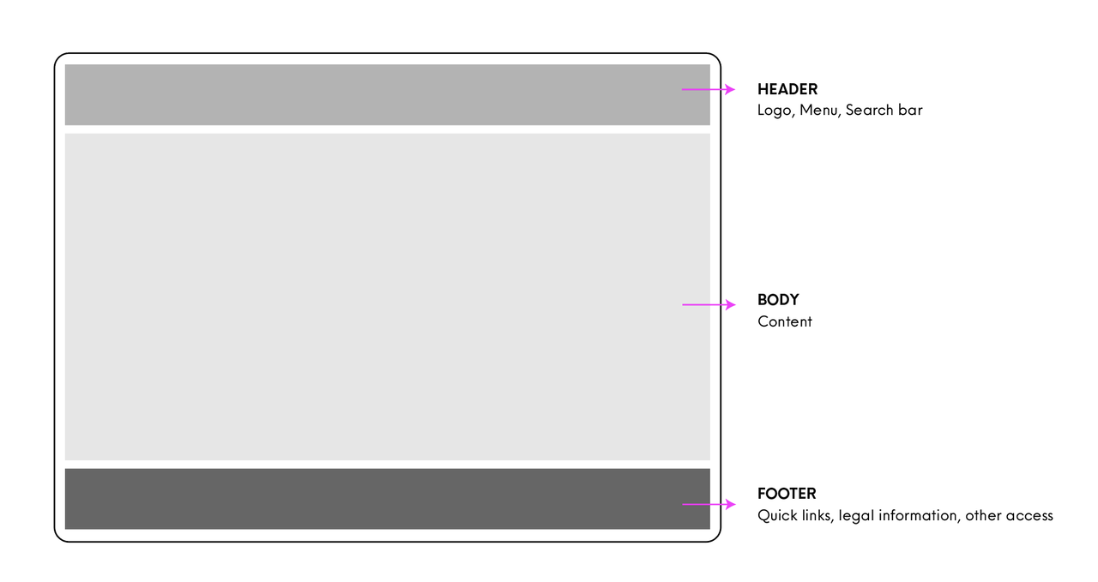

**3.3.2**  **Aligment, margins & space**

Margins are important to define the page limits and unify your layout content.

Choosing an alignment to the elements helps to keep your design good and clear, as well as defining the space between each one.

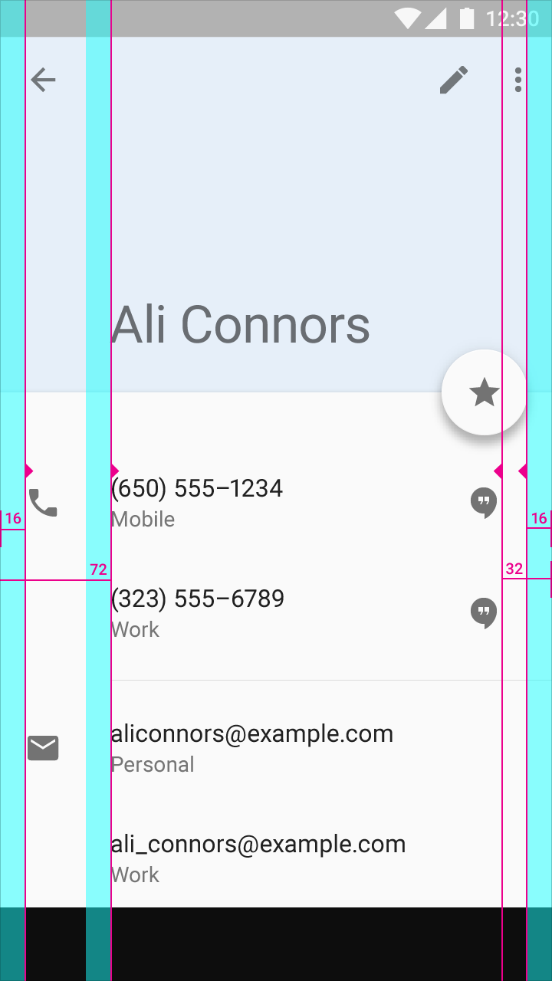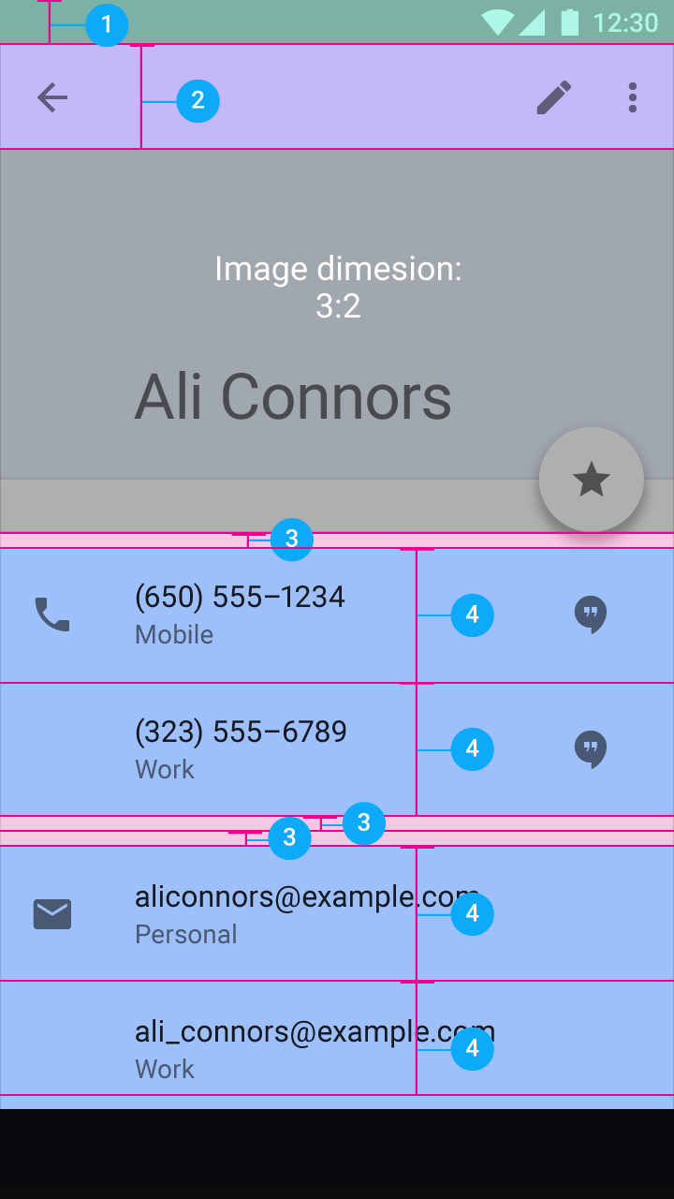

**3.3.3 Some Common Elements Examples**

* **Navbar**

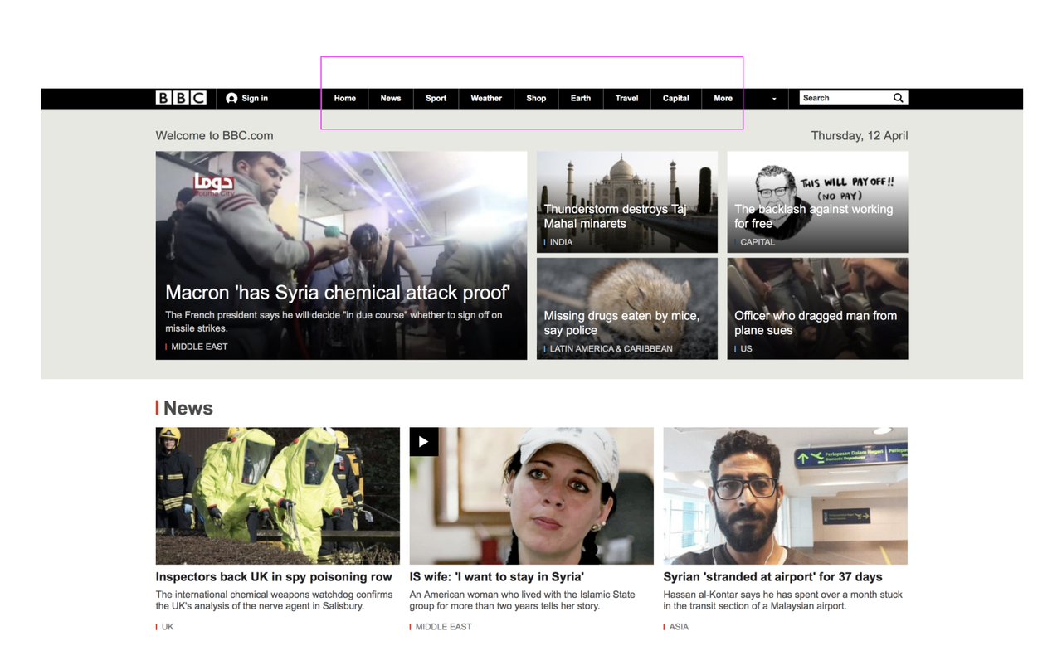

* ***Hamburger Menu***

Selecting (tapping or clicking) this button results in a menu being revealed (sliding out or popping up), which distinguishes it from a menu bar, which is always on display.



* **Buttons and CTA's**

*A button is any element that triggers an action: ex. go to a link, open a window, show options…*

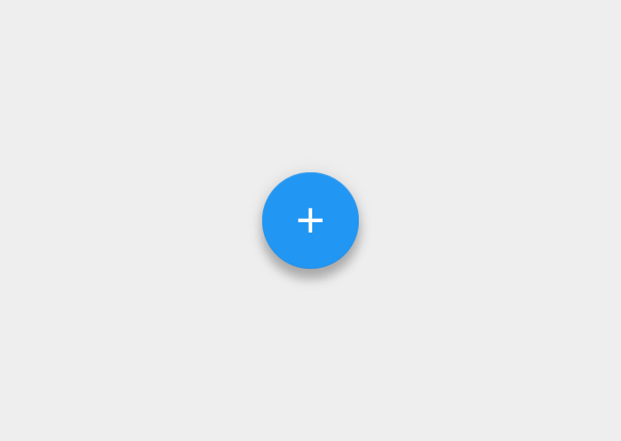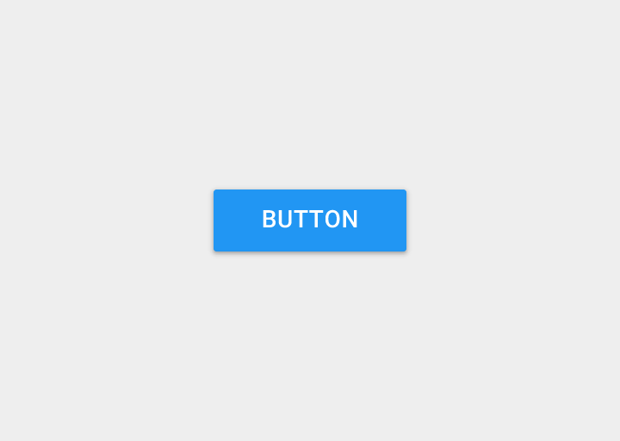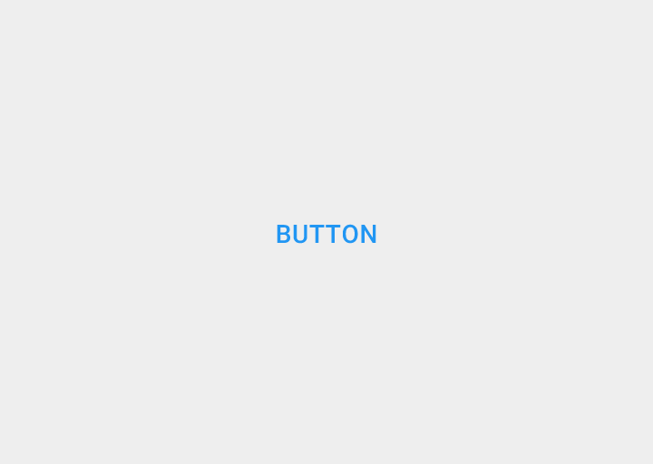

There several ways to design a buttons, but the most important thing to keep in mind is keeping a standard and making then start out from the rest of the layout.

* **CTA**

A call-to-action (CTA) is an image or line of text  (mostly represented by buttons on web) that prompts your visitors, leads, and customers to take action. It is, quite literally, a "call" to take an "action." An example of a CTA is “click here”.

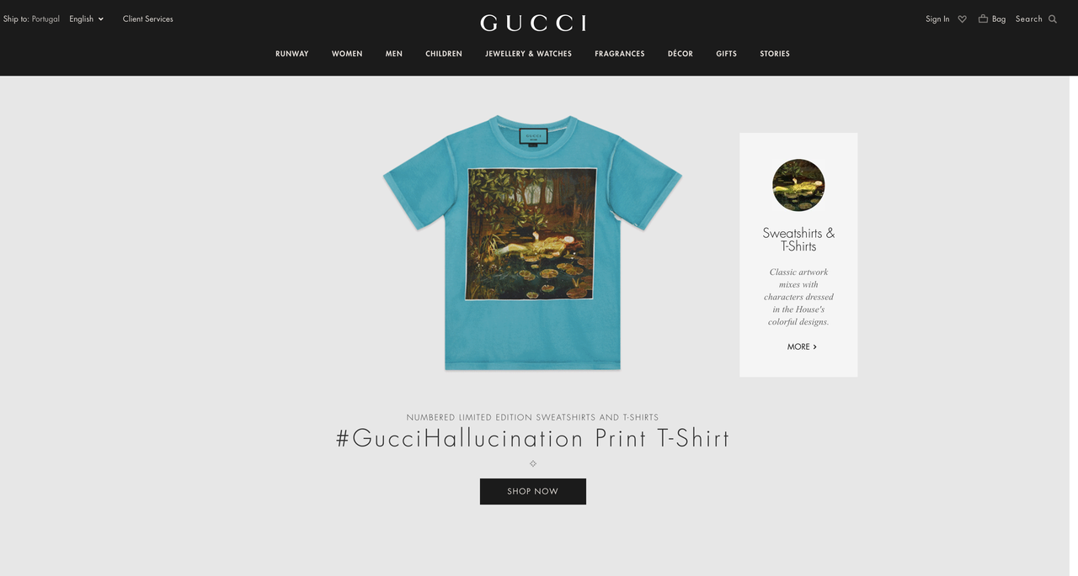

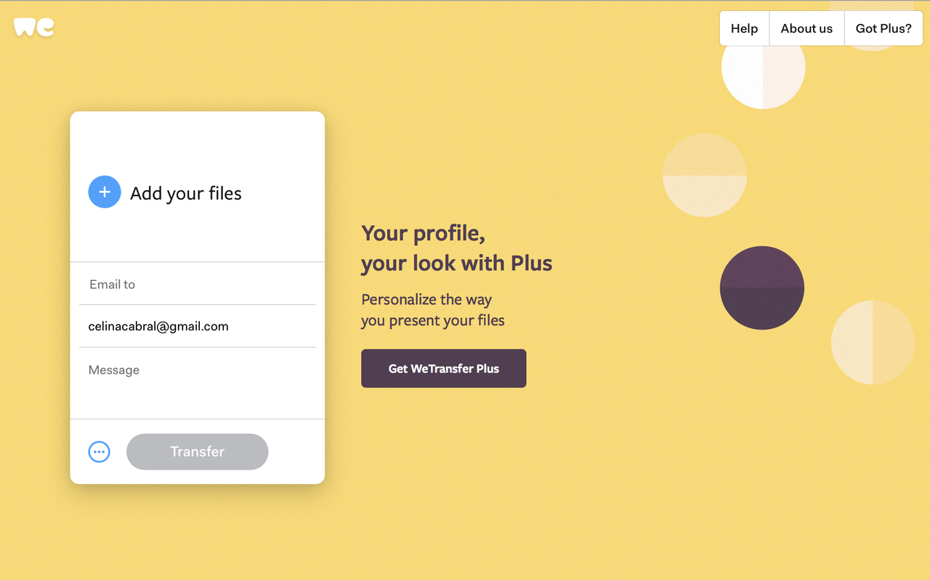

* **Icons**

Graphic elements that helps to efficiently communicate a message via a commonly understood visual language. Usually helps the user to recognise information or replace texts.



* **Forms**

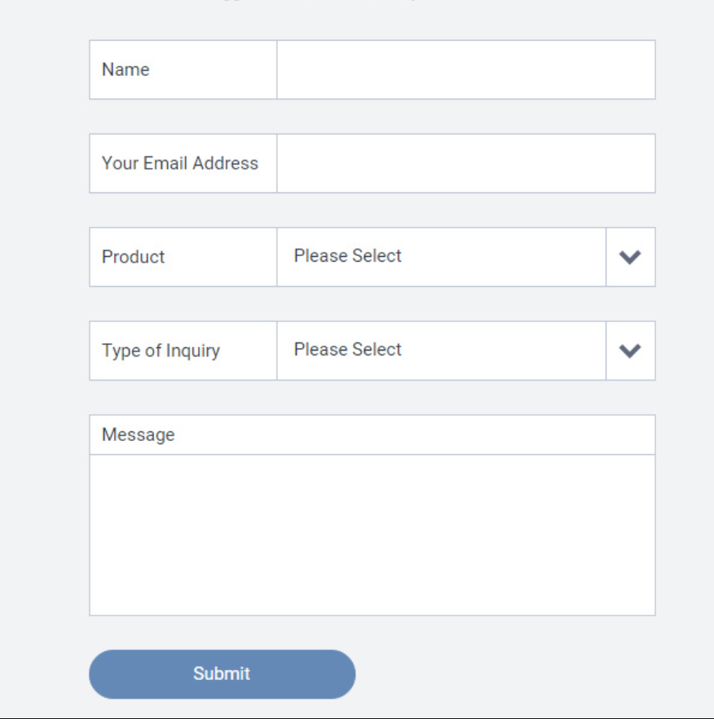

# 4. Before all: Plan first

**Wireframes**

Wireframe is a visual guide that represents the skeletal framework of a website, software or application.

Wireframes are also a base for UI Designers and Developers to work with.

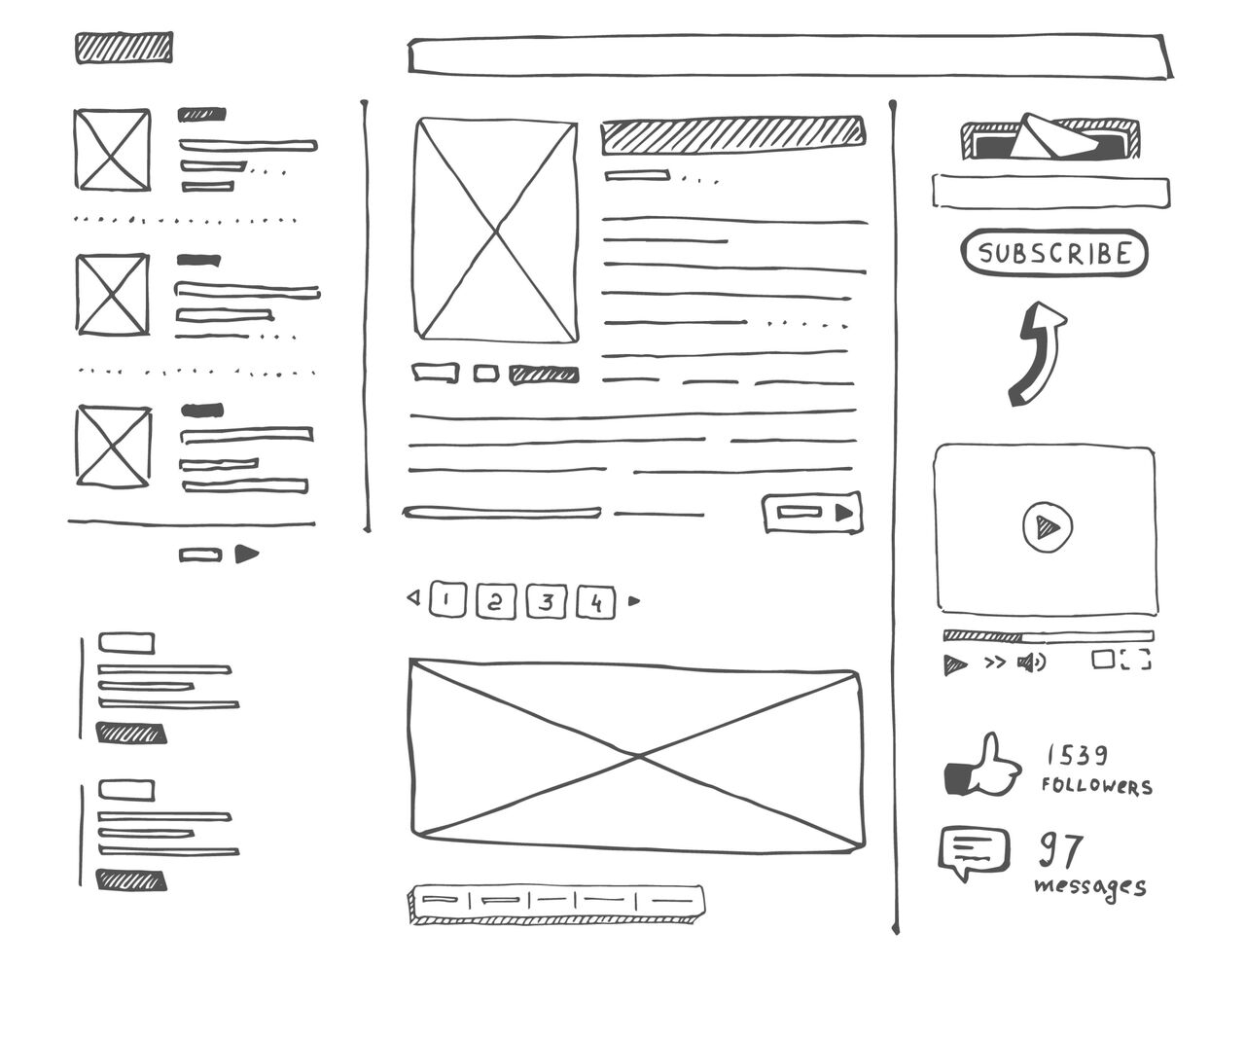

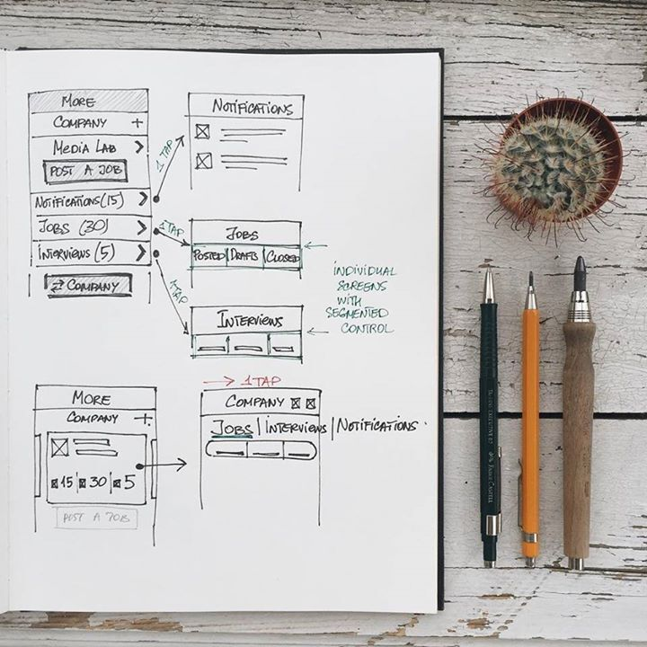

Online tool for wireframes: <https://wireframe.cc> / <https://balsamiq.cloud>

# 5. Grids

In the digital world, the **grid system** acts similarly to the print layout in organizing the elements on the page. It provides a guide for designers to create multiple layouts that support responsive themes for different screen sizes.

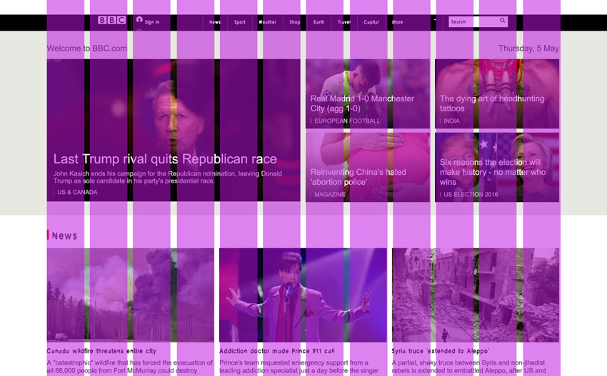

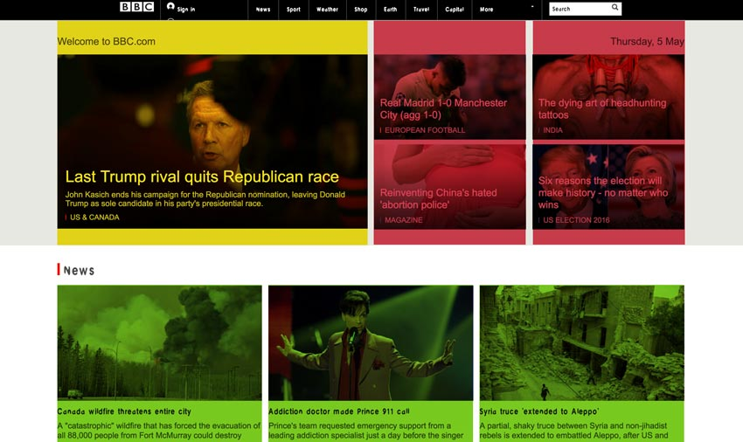

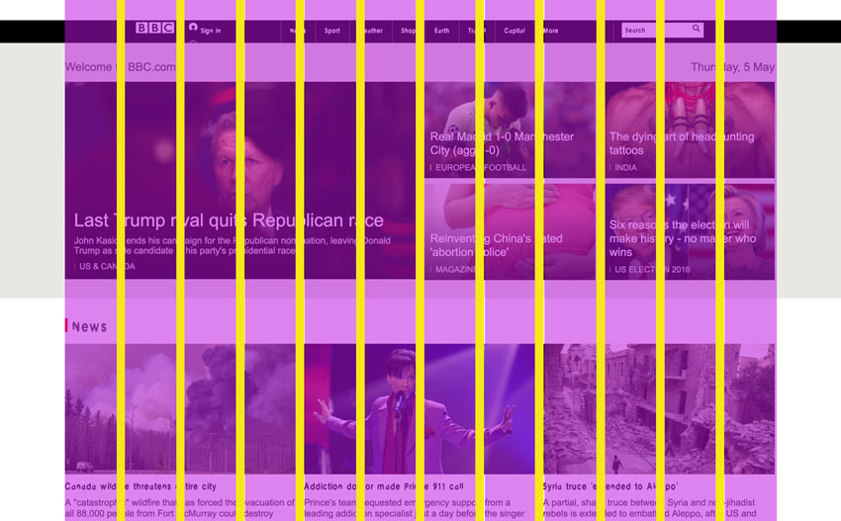

**More reading:** <https://blog.prototypr.io/9-best-grid-system-for-web-mobile-ui-265c68d30c09>

# 

# 6. Animations and transitions

Animations and transitions are elements that can be added to offer a pleasant experience on navigation, warn and guide the users.





**Important:** Remember animations should be used if it really adds something on the interface. The use of too much animations and transitions without a good reason can confuse the user.

# 7. Typography

## Your font choice should reflect how you want to be perceived as a brand/service.

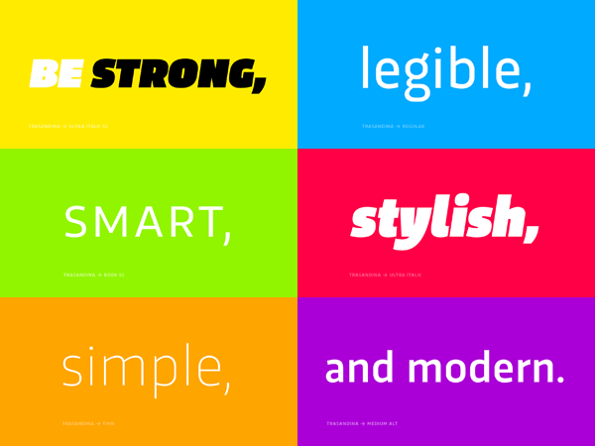

**Typography involves:**

* selecting typefaces
* font sizes
* line-spacing (leading)
* letter-spacing (tracking)
* adjusting the space between pairs of letters ( kerning)

There are different types of fonts:

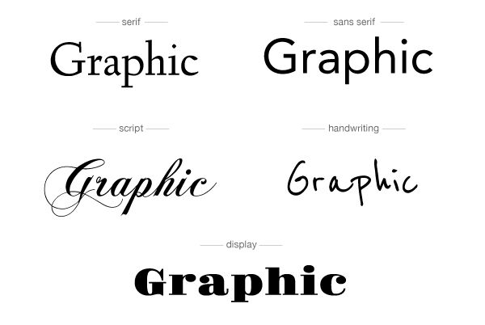

And different ways to use them:

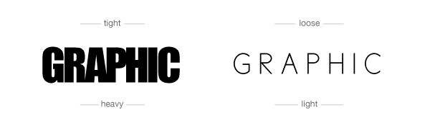

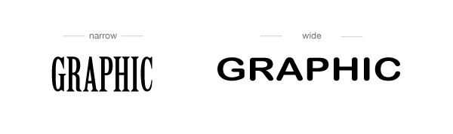

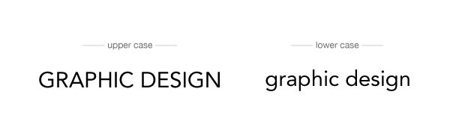

Always look for good references, have some inspiration!

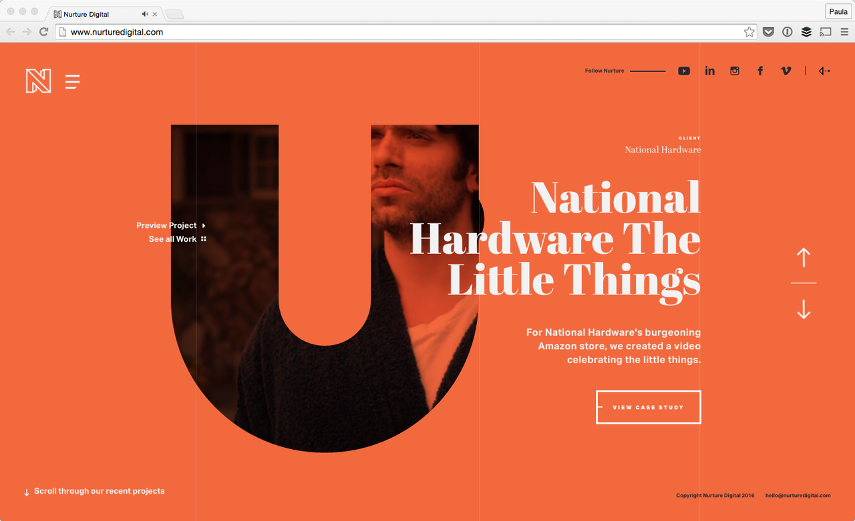

Inspiration link: [17 Websites with Typography-Driven Design](https://www.designbombs.com/websites-typography-driven-design/)

# 8. Best Practices

## 1. Whitespace: About Improving Comprehension

Whitespace should make both scanning and reading content easier and more predictable.

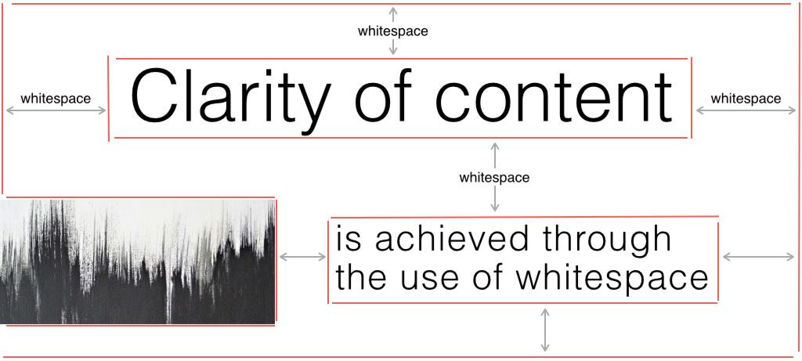

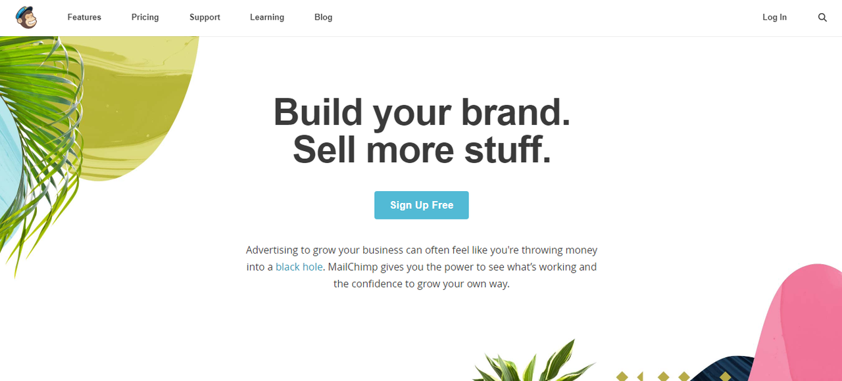

## 2. Visual Hierarchy and Composition

Hierarchy and composition help to guide the reader’s eyes to the most important information and organize the content by their importance.

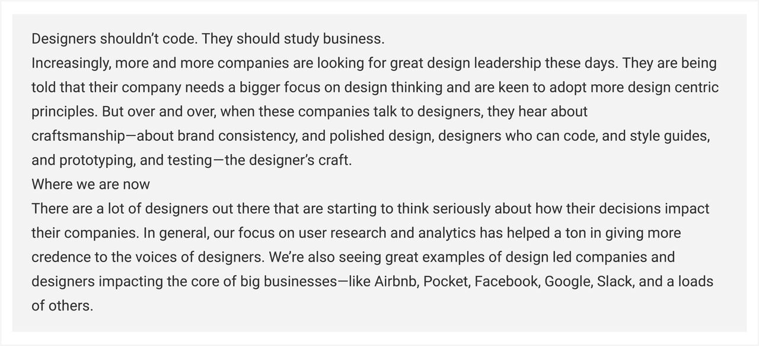

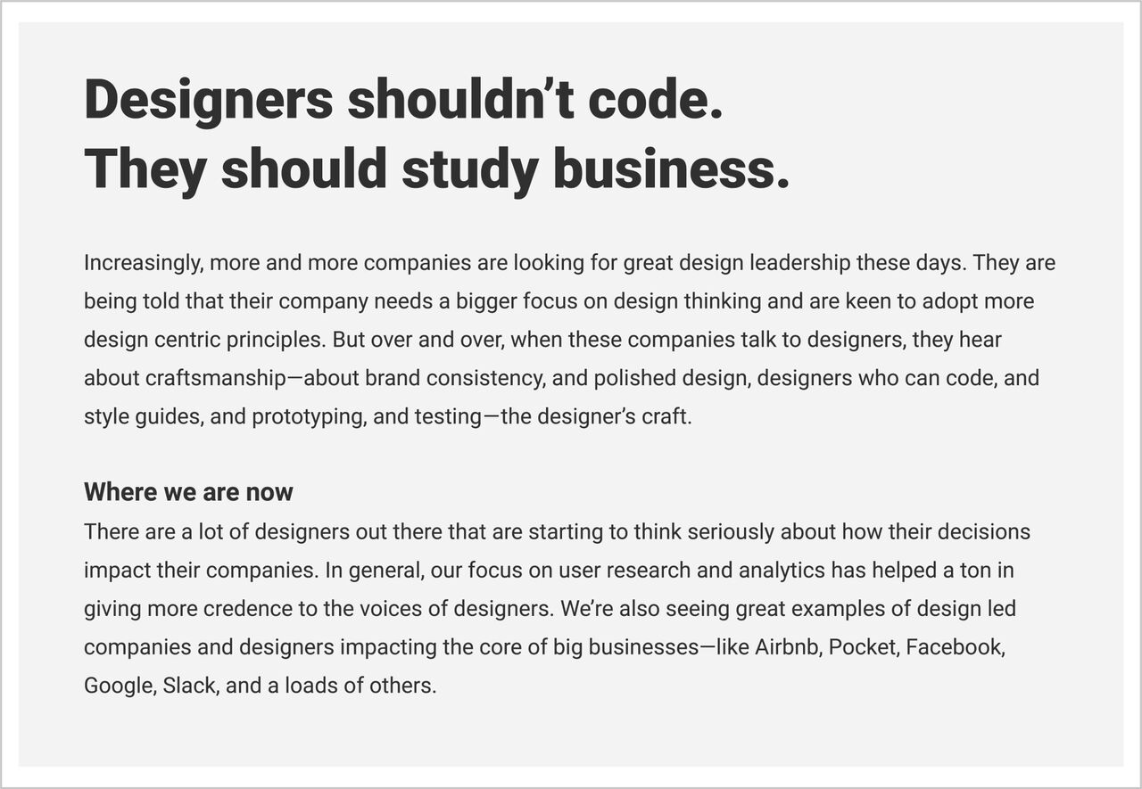

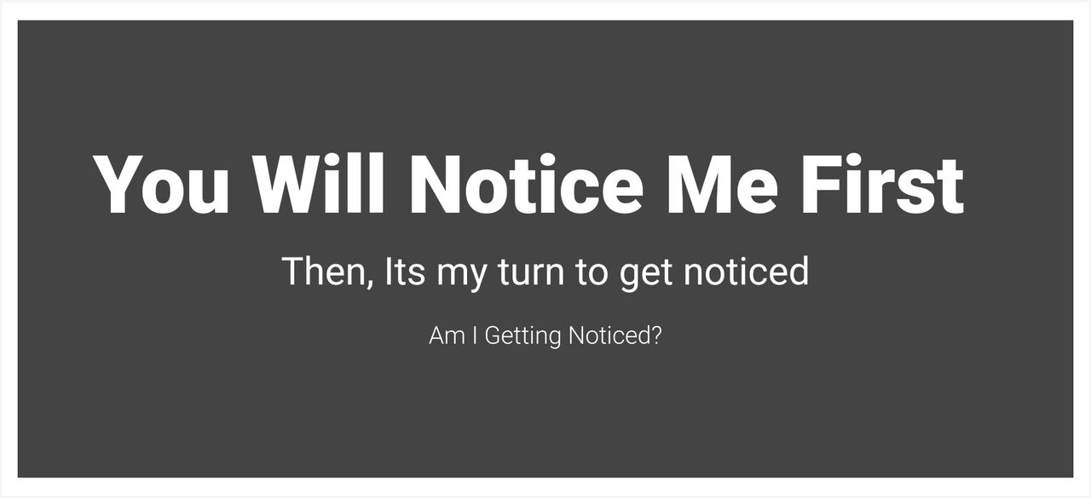

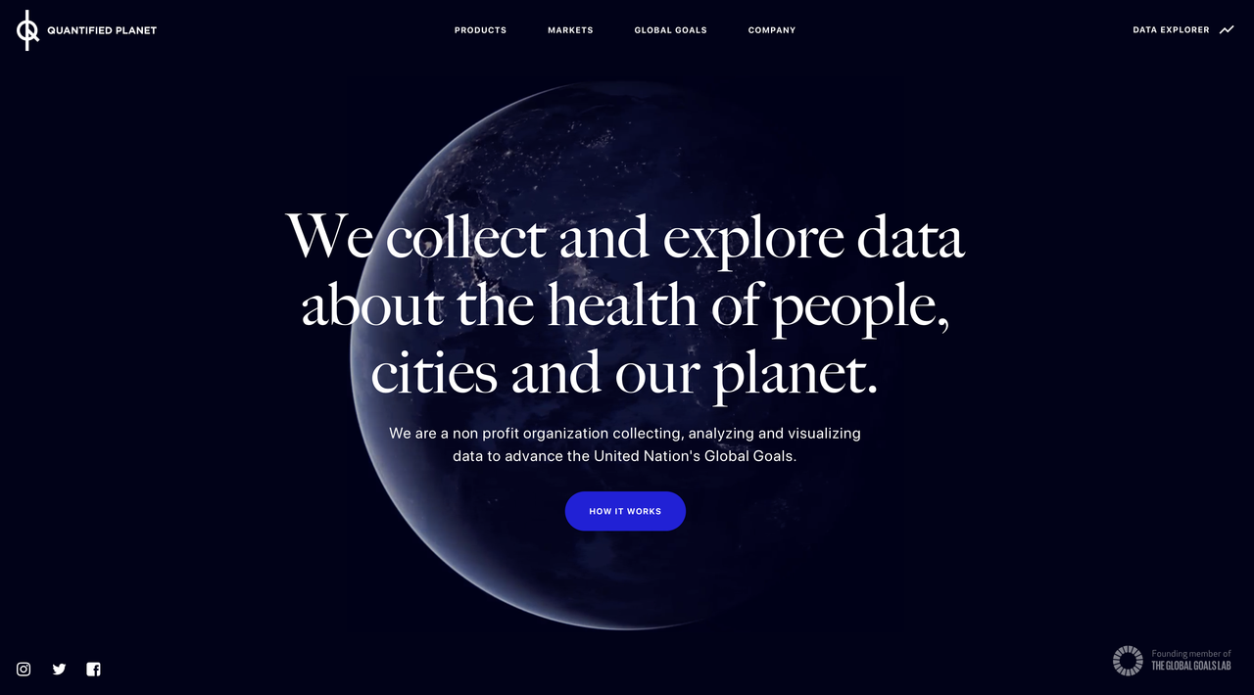

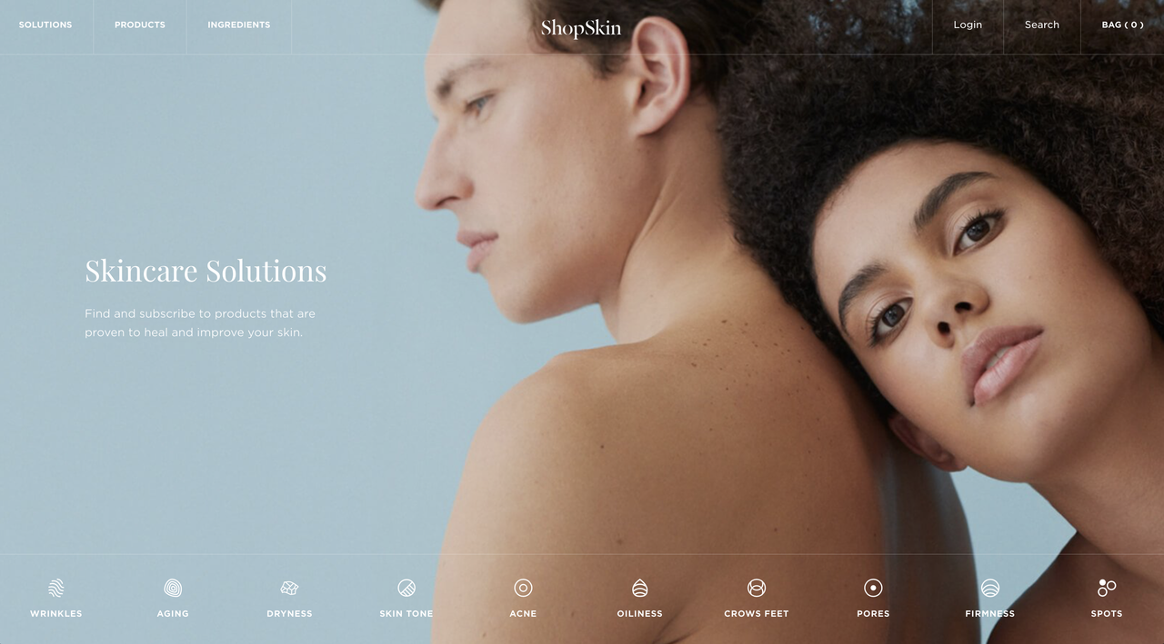

## 3. Color and contrast

Colors are not only an aesthetic element. They should help the user through the navigation.

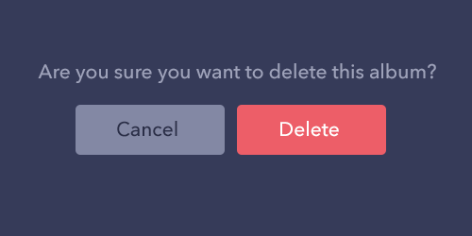

A good contrast is essencial to make information clear:

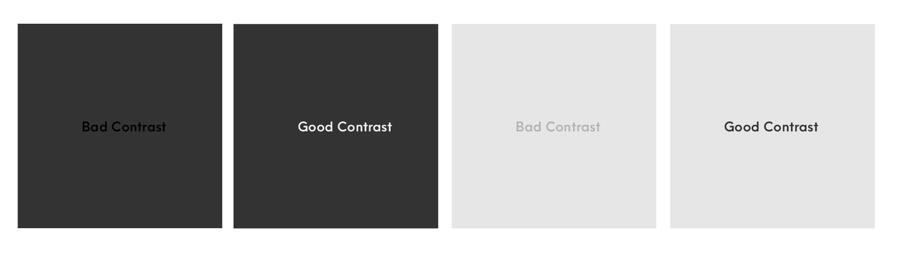

## 4. Usability

**It's making the user journey easier!**

Always imagine how information could be organised in order to show the most important thing to that user in a particular situation:

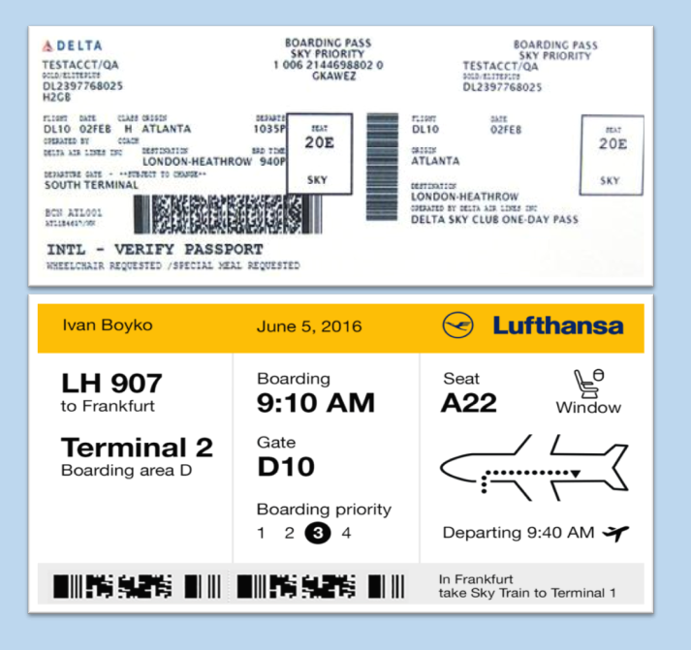

## 5. Accessibility

To accommodate all users, avoid small and thin text settings, low contrasts and make sure all important information readable.

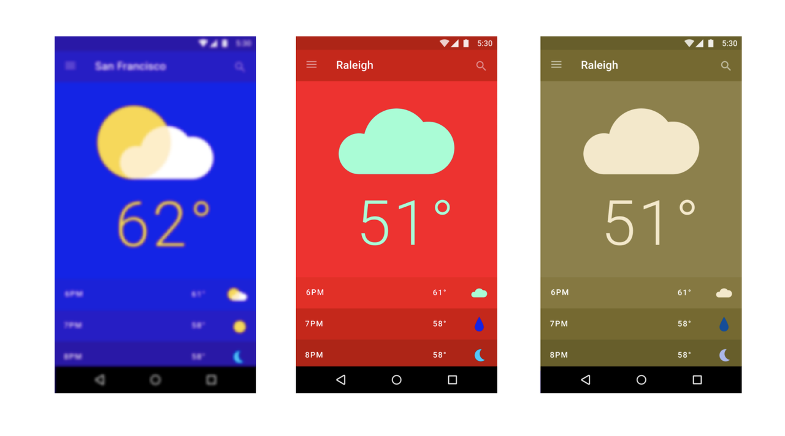

## 6. Font Choice and Font Pairing

The use of good fonts are essential to a great design. But picking fonts can seem like an impossible dark art for most people.

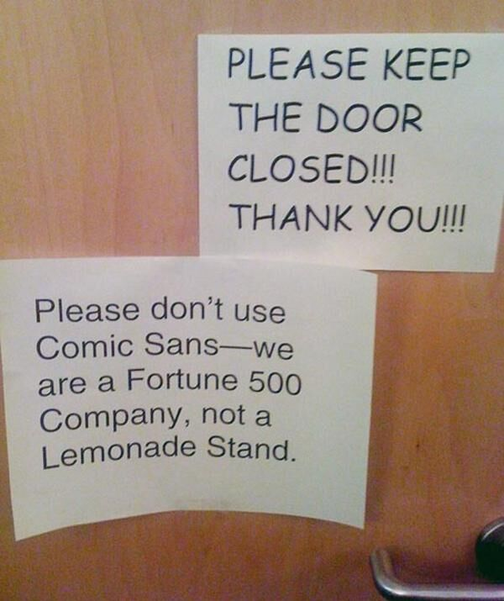

You can always play with the right fonts!

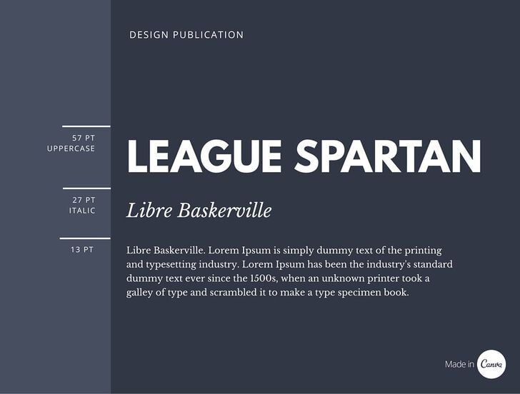

See more here: [The Ultimate guide to Font Pairing](https://www.canva.com/learn/the-ultimate-guide-to-font-pairing/)

Font pairing  online tool  <http://fontjoy.com>

# 9. Design Tools

There are many choices for design tools:

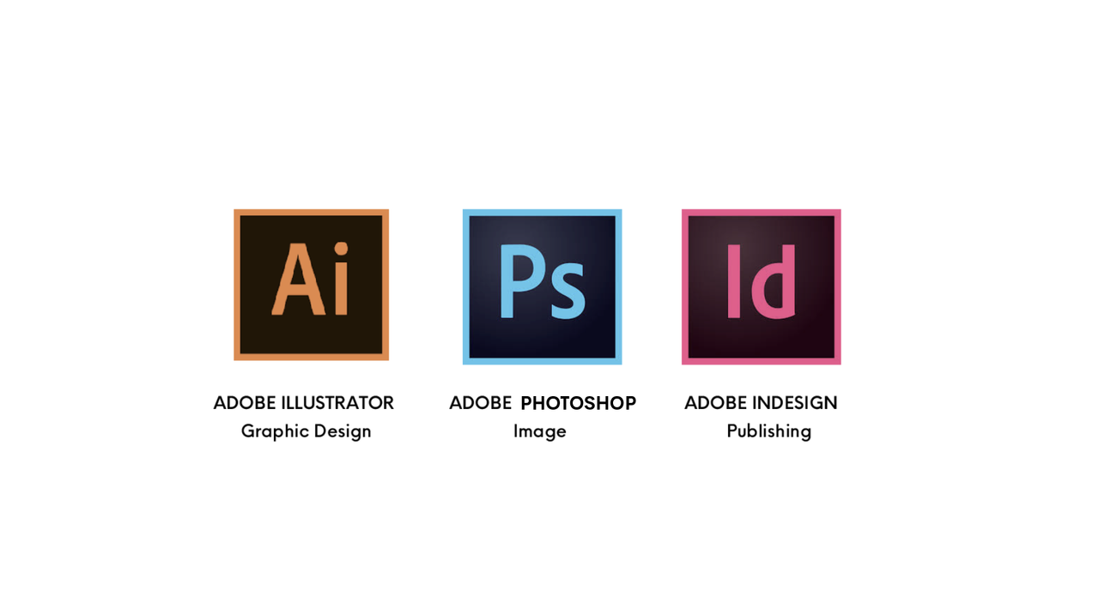

Some specific for UI/UX design:

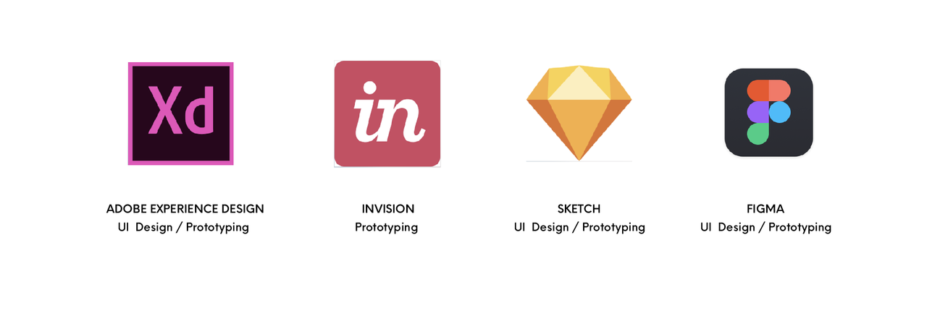

# 10. Now….Hands on! Let's design on Figma

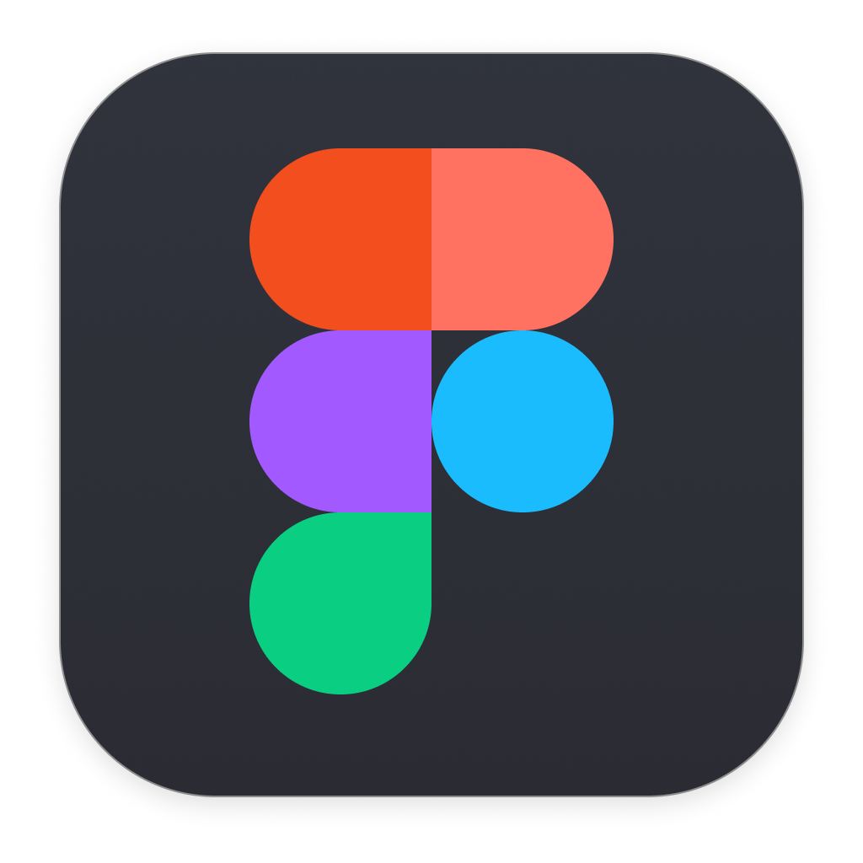

## What is Figma?

Figma is an Interface Design App.

It offers real-time collaboration with others, what is good when working with big teams.

Figma's tools are easy to use and prepared to web applications. (Units, colors, canvas sizes, etc)

# 11. Working with Figma - Quick Tips

1. Creating a project

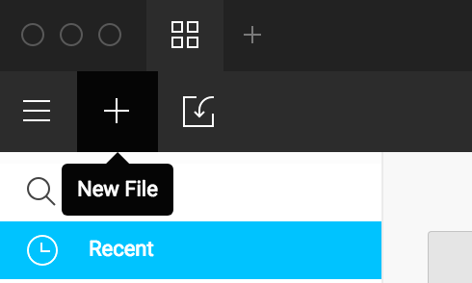

1. Creating a canvas

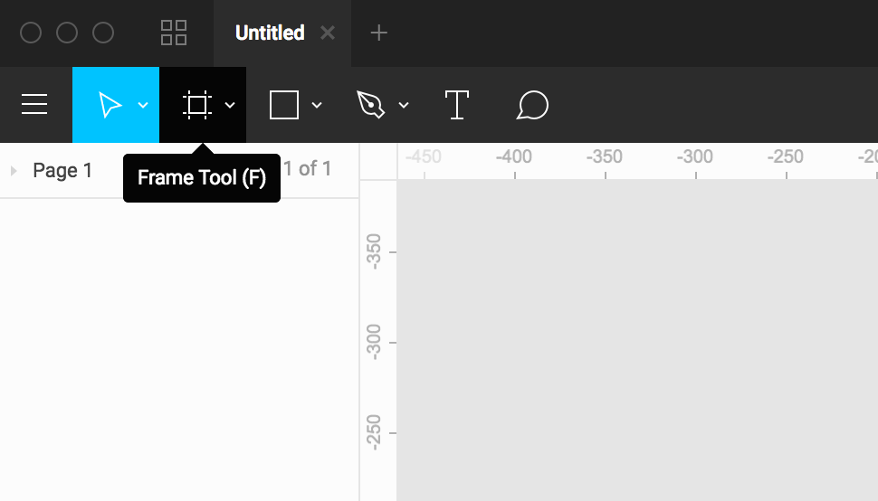

1. Defining the size of your canvas (desktop, mobile, tablet, etc) on the **right panel**

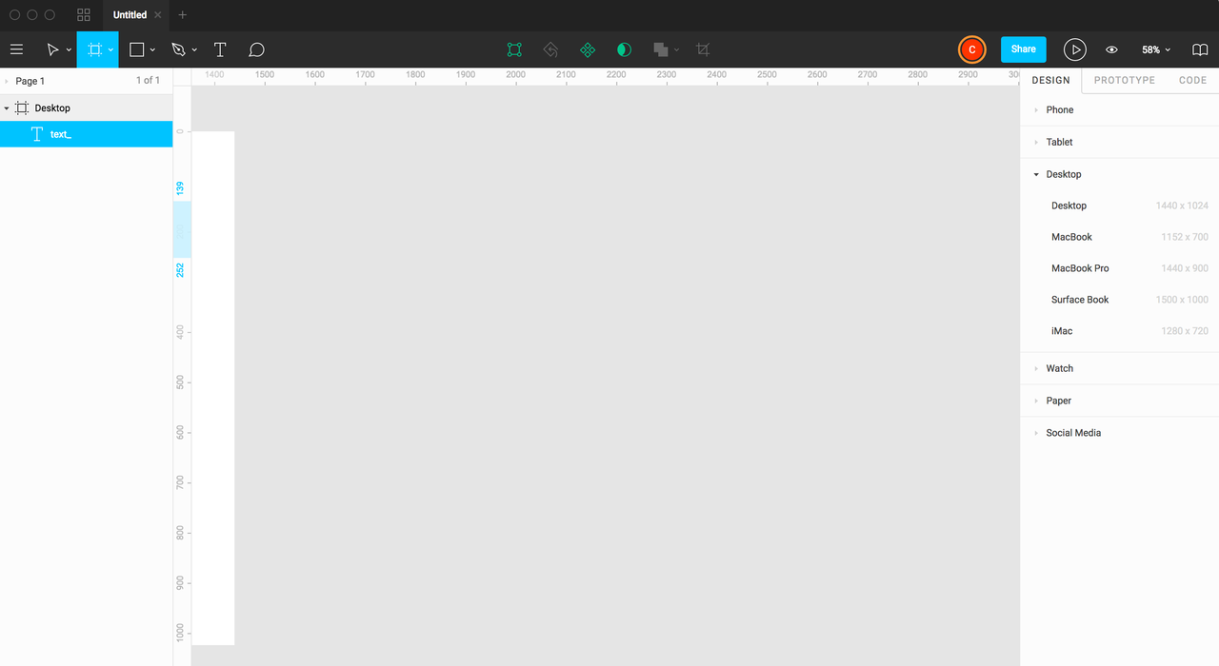

1. Creating Grids

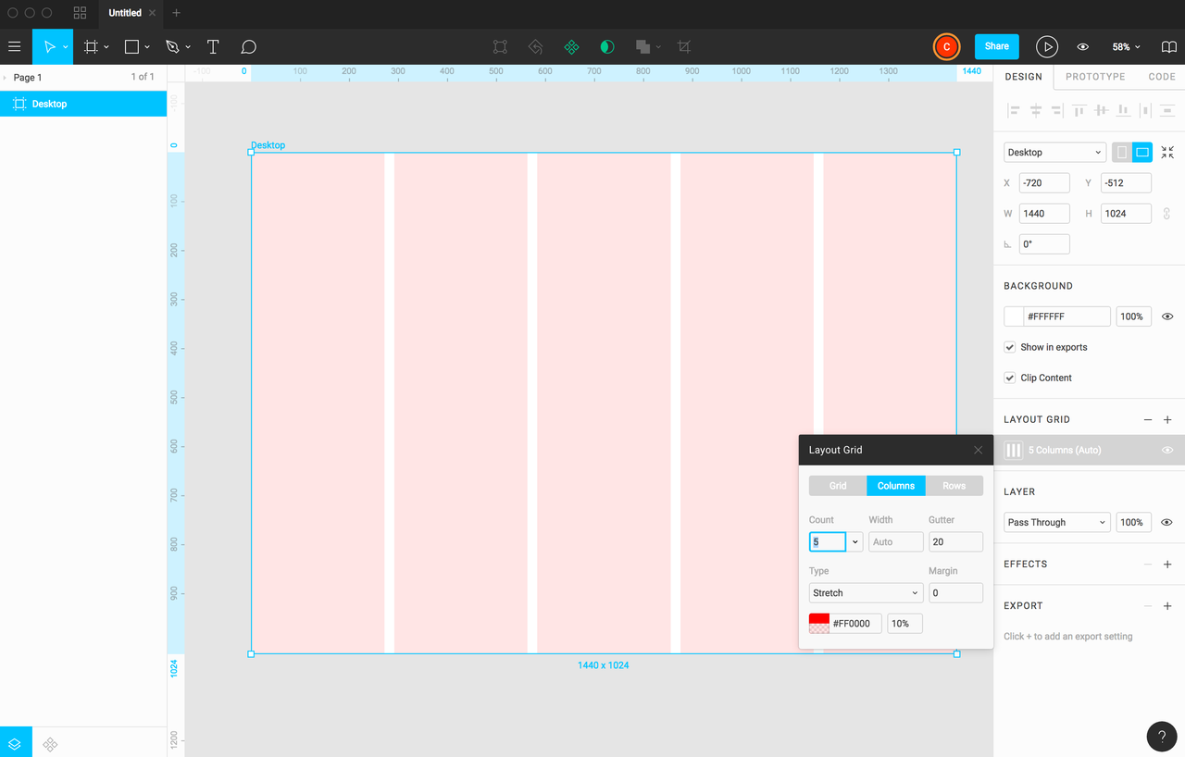

1. Adding texts

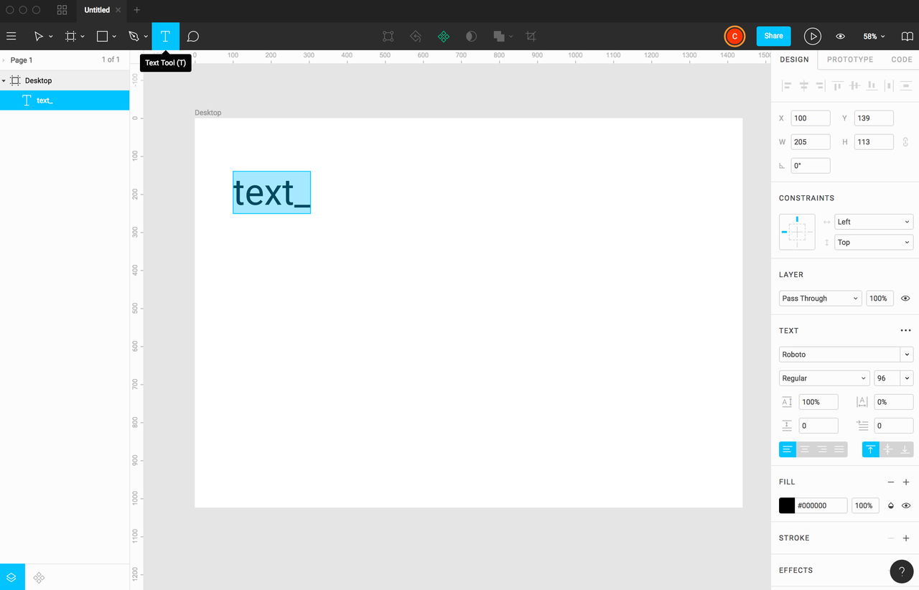

1. Adding shapes and images

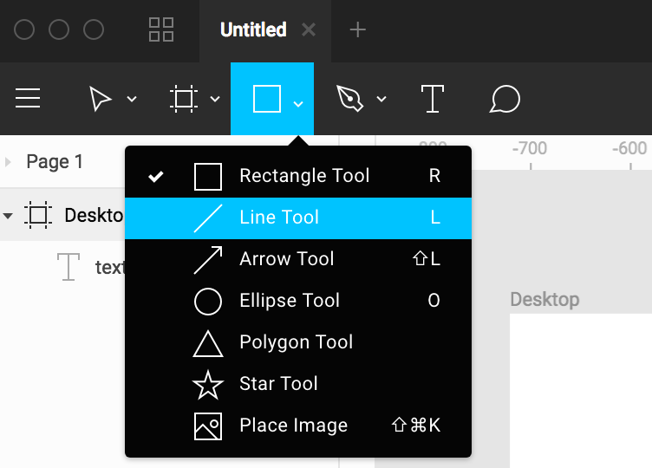

1. Getting the CSS code

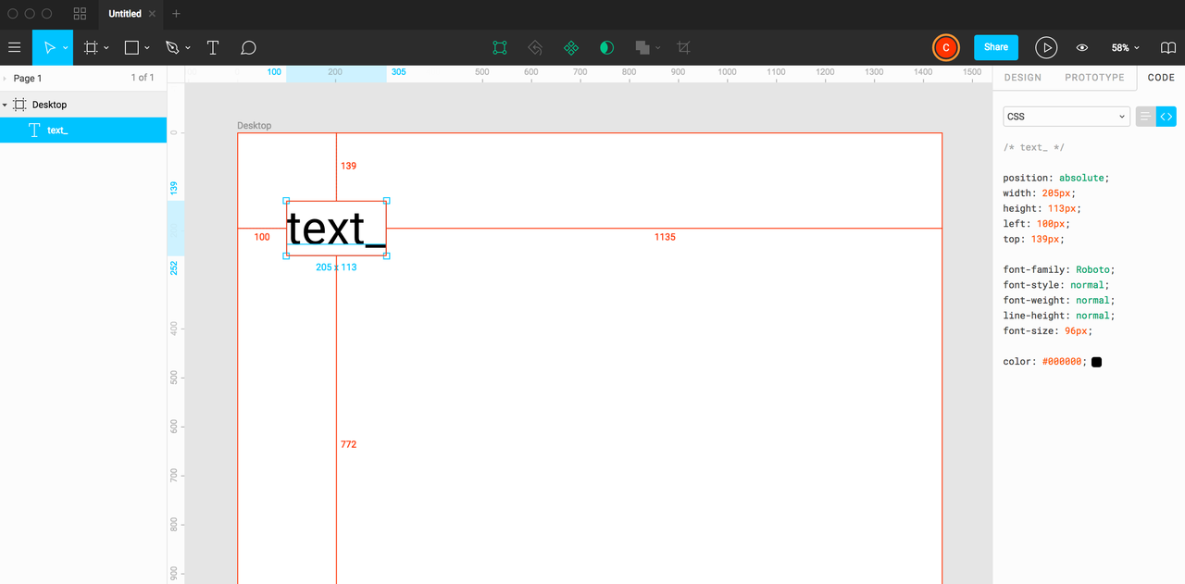

# woman technologist Task:

Recreate [SheCodes](https://shecodes.io/) website using Figma.

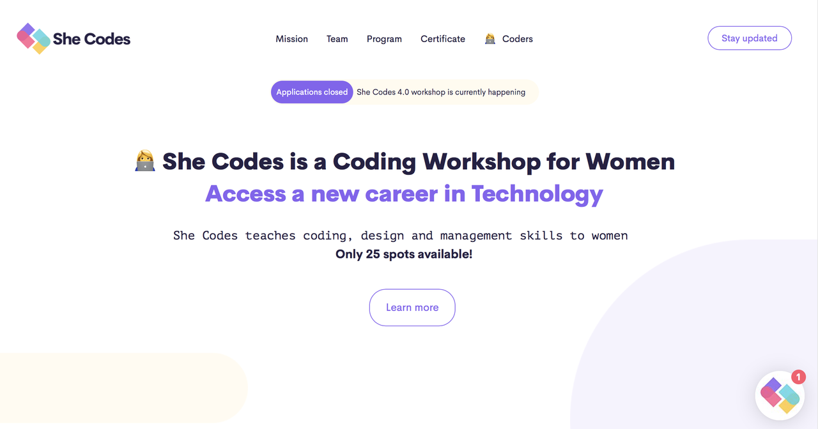

## Assets:

**Fonts**

Headlines, Montserrat - <https://fonts.google.com/specimen/Montserrat>

Paragraph, PT Mono - <https://fonts.google.com/specimen/PT+Mono>

User Avatars - <https://randomuser.me/>

**Basic desktop grid references:**

12 unit grid

1140px width

150px margin

# nerd face Helpful links and complementary reading:

**Information**

<https://www.interaction-design.org/literature>

**Good Design reading**

<https://uxplanet.org>

<https://blog.figma.com>

<https://airbnb.design>

<https://99u.adobe.com>

<https://www.invisionapp.com/blog>

**UI references and sources**

<https://material.io/guidelines/material-design/introduction.html>

<https://dribbble.com>

<https://www.uplabs.com>

<https://ui8.net>

**Online tools for UX/UI**

<https://wireframe.cc>

<https://balsamiq.cloud>

<https://www.uxpin.com>

<https://www.invisionapp.com>

**Websites design inspiration**

[https://www.awwwards.com](https://www.awwwards.com/websites/)

**Typography**

Fonts for web: <https://fonts.google.com>

Font Trends: <https://www.typewolf.com>

Discover what font the websites use (plugin): <https://www.fontface.ninja/>